Electronic supporting information for

**Cation overcrowding effect on the oxygen evolution reaction**

Jun Huang,1,2* Mengru Li,1 Mohammad J. Eslamibidgoli,2 Michael Eikerling,2,3 Axel Groß1,4

1 Institute of Theoretical Chemistry, Ulm University, 89069 Ulm, Germany

2 Institute of Energy and Climate Research, IEK-13: Theory and Computation of Energy Materials, Forschungszentrum Jülich GmbH, 52425 Jülich, Germany

3 Jülich Aachen Research Alliance: JARA-Energy, 52425 Jülich, Germany

4 Helmholtz Institute Ulm (HIU) Electrochemical Energy Storage, 89069 Ulm, Germany

Corresponding author, email: jun.huang@uni-ulm.de

Contents

**S1. Model fitting** 2

**S2. An extreme case with one step having a much larger activation energy** 2

**S3. Zero-point vibrational corrections** 3

**S4. Spin magnetic moments for Oxygen and Nickel atoms** 3

**S5. Variations in experimental polarization curves on the same system measured by different laboratories** 5

**S1. Model fitting**

Model fitting was conducted using the built-in Matlab function ‘ga’ based on the genetic algorithm. There are eight variables including four charge numbers of adsorbates and four activation energies of the four elementary steps. The lower and upper bounds for charge numbers are -0.1 and 0, respectively. The lower and upper bounds for activation energies are 0.3 eV and 0.8 eV, respectively. The number of maximum generations is ten. The experimental data used for model fitting are taken from Michael et al. (Ref.24 in the paper). The objective function is the sum of the deviation between the model and experiments at three cations.

**S2. An extreme case with one step having a much larger activation energy**

Figure S1 exhibits the model-calculated results for an extreme case where the activation energy of the first step is increases to 0.98 eV, much higher (>0.6 eV) than other steps. Figure S1 (a) shows the polarization curve. Although the magnitude of the current density is orders lower than the base case, the activity trend of Cs+> Na+>Li+ remains. Figure S1(b) displays the four resistance terms. As the first step is made much more sluggish, the rate-determining term is the first term above 1.4 VRHE.

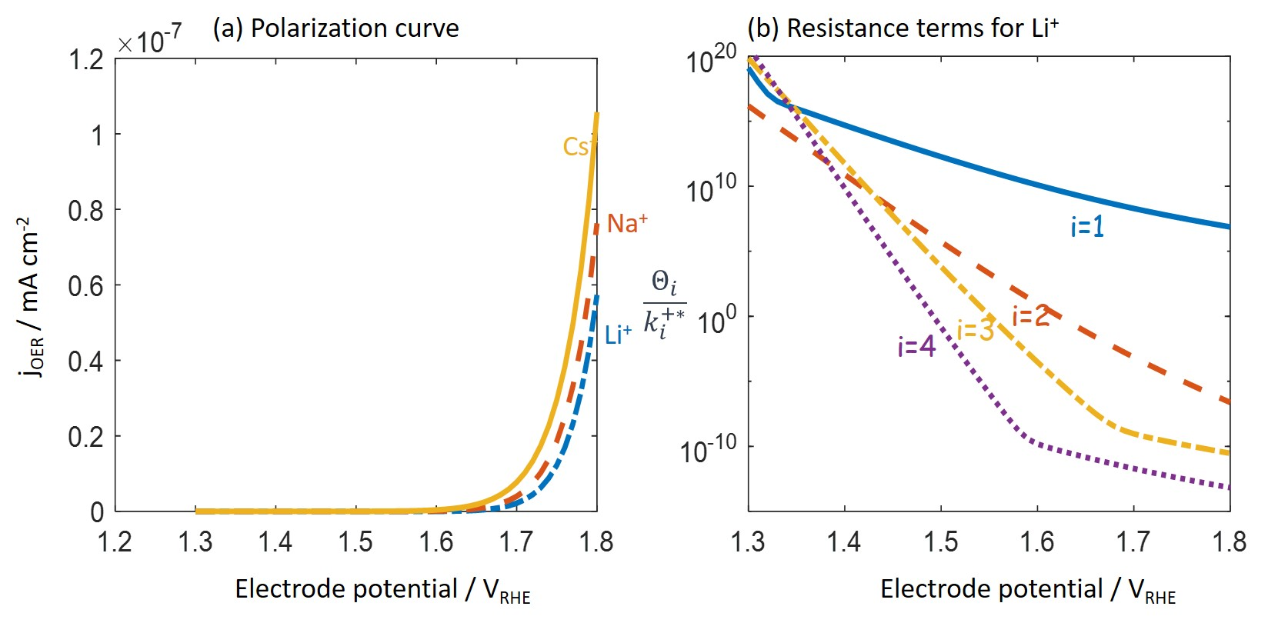

Figure S1. (a) Model-calculated polarization curves for OER in 0.1 MOH (M=Li+, Na+, Cs+) for the case with and other model parameters listed in Table 1. (b) Four resistance terms as a function of the electrode potential for the case of M=Li+.

**S3. Zero-point vibrational corrections**

The zero-point vibrational and vibrational entropy corrections have an appreciable influence on the binding energies of surface species, thus on the equilibrium potentials of the elementary steps.

As shown in Figure 1, the catalyst structure changes a lot during the deprotonation step (), the oxygen removal step ) and the recovering step of the catalyst (). In those steps, the adsorbates are a part of catalyst. As a result, the calculation of the vibrational frequency requires to relax not only the adsorbates but also the catalyst itself, which is time-consuming.

For the steps without strong catalyst structure change () and (), we can estimate the zero-point vibrational correction to the reaction free energy using literature results.1 We obtain for the step, and for the step.

With above considerations, we did not include the zero-point vibrational corrections. Instead, we allow the equilibrium potentials of each step to vary within 0.3 V, and show that the model-based conclusion is robust against such variations.

**S4. Projected magnetic moments for oxygen and nickel atoms**

The projected magnetic moments for surface oxygen and nickel atoms are listed in Table S1, which were calculated through the charge partitioning scheme suggested in refs.2, 3

With the removal of one H atom from the O-Ni-OH surface, the spin magnetic moment of the Ni atom beneath the deprotonation site changes from 1.05 to 0.09, which means that the oxidation state of that Ni atom changes approximately from 3+ to 4+, which is consistent with the results of Govind Rajan et al.4 In addition, the spin magnetic moment of the oxygen atom that is previously bonded with the deprotonated H atom changes from -0.15 to -0.07.

After the removal of the lattice oxygen from the O-Ni-O surface, the spin magnetic moment of the Ni atom that is bonded with that O atom changes to -1.84, indicating spin flip as pointed out by the reviewer. However, details of the process of spin flip can only be obtained through time-dependent DFT, which was not attempted in this work.

**Table S1** Projected magnetic moments on surface Ni and O atoms (atoms related to the reaction site are highlighted in blue)

|  |  |  |  |  |  |
| --- | --- | --- | --- | --- | --- |
| Stoichiometric  Surface (O-Ni-OH) | | Partly Deprotonated Surface (O-Ni-O) | | Surface with oxygen vacancy () | |
| Oxygen | Nickel | Oxygen | Nickel | Oxygen | Nickel |
| -0.23 | 1.14 | -0.16 | 1.14 | -0.09 | 1.15 |
| -0.23 | 1.14 | -0.25 | 1.20 | -0.17 | 1.18 |
| -0.23 | 1.14 | -0.25 | 1.07 | -0.17 | 1.11 |
| -0.23 | 1.14 | -0.25 | 1.14 | -0.05 | 1.16 |
| -0.15 | 1.05 | -0.14 | 1.05 | -0.05 | 1.05 |
| -0.15 | 1.05 | -0.14 | 1.04 | -0.09 | 1.04 |
| -0.15 | 1.05 | -0.07 | 0.09 | - | -1.84 |
| -0.15 | 1.05 | -0.15 | 1.07 | -0.13 | 1.01 |

**S5. Variations in experimental polarization curves on the same system measured by different laboratories**

In Fig. S2, we compare the polarization curves of OER at NiOOH in purified 0.1 MOH (M=Li+, Na+, Cs+) measured by two laboratories.5, 6 Though the activity trend of Cs+>Na+>Li+ is shared by both, noticeable deviations in the magnitude of the current density and the detailed profiles of the polarization curves are found.

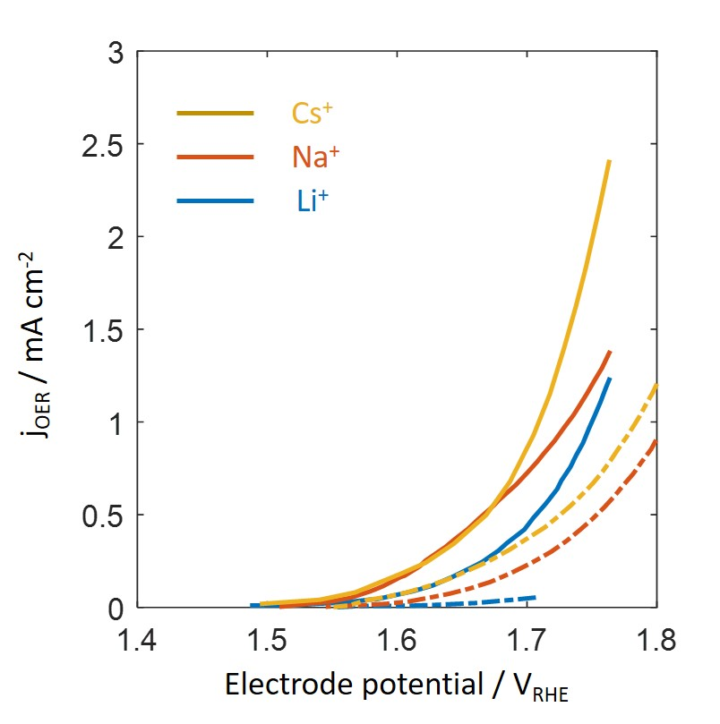

Fig. S2. Experimental polarization curves for OER on NiOOH in purified 0.1 MOH (M=Li+, Na+, Cs+): solid lines represent data taken from Michael et al.6 dashed lines represent data taken from Garcia et al.5

References

1. Doyle, A. D.; Bajdich, M.; Vojvodic, A., Theoretical Insights to Bulk Activity Towards Oxygen Evolution in Oxyhydroxides. *Catalysis Letters* **2017,** *147* (6), 1533-1539.

2. Limas, N. G.; Manz, T. A., Introducing DDEC6 atomic population analysis: part 2. Computed results for a wide range of periodic and nonperiodic materials. *RSC Advances* **2016,** *6* (51), 45727-45747.

3. Manz, T. A.; Limas, N. G., Introducing DDEC6 atomic population analysis: part 1. Charge partitioning theory and methodology. *RSC Advances* **2016,** *6* (53), 47771-47801.

4. Govind Rajan, A.; Martirez, J. M. P.; Carter, E. A., Facet-Independent Oxygen Evolution Activity of Pure β-NiOOH: Different Chemistries Leading to Similar Overpotentials. *Journal of the American Chemical Society* **2020,** *142* (7), 3600-3612.

5. Garcia, A. C.; Touzalin, T.; Nieuwland, C.; Perini, N.; Koper, M. T. M., Enhancement of Oxygen Evolution Activity of Nickel Oxyhydroxide by Electrolyte Alkali Cations. *Angewandte Chemie International Edition* **2019,** *58* (37), 12999-13003.

6. Michael, J. D.; Demeter, E. L.; Illes, S. M.; Fan, Q.; Boes, J. R.; Kitchin, J. R., Alkaline Electrolyte and Fe Impurity Effects on the Performance and Active-Phase Structure of NiOOH Thin Films for OER Catalysis Applications. *The Journal of Physical Chemistry C* **2015,** *119* (21), 11475-11481.